Planet Resources Hunter

Team:

**Ultimate Upon Great Fire the Book Heroic one**

CCC Heep Woh College

Hong Kong

Ex-officer: Mr. Hsia Ming Wai  
Administrator: Mr. Fung Wah Sing

Members:  
Mak Kin Wing

Lam Ka Chun  
Leung Ho Kwan

Contents

Inspiration 3

Brief Introduction 4

System construction 4

Workflow 5

Mechanic Design 6

Base 6

Prospector 7

Resource-hunter 8

Railways 8

Railway-replenisher 9

Energy mines 9

Program Design 10

Program Flowchart 10

Base 10

Prospector 11

Resource-hunter 12

Railway-replenisher 13

Program Feature : Base………………………………………………………………..………….16

Program Feature : Prospector………………………………………………………………….23

# Inspiration

Since the steam machine had been invented during the industrial revolution, scientific development of mankind has been being advancing. This relies heavily on the natural resources on our mother planet, the Earth. However, it is estimated that the mostly-consumed fossil fuels will be used up in near future. This makes many scientists try to work a solution out to the resource crisis.

Some countries has made renewable energy resources into practice while some has invested on nuclear power plants in the past few ten years. Unfortunately, Renewable energy such as wind power, hydro-power and solar power can only provide humans with a limited amount of energy. Moreover, nuclear accidents like the Chernobyl disaster as well as the Fukushima Daiichi nuclear disaster also reminded humans that the cost-effectiveness of nuclear power comes with the terrifying potential dangers. It is extremely difficult for the scientists to work a perfect way out towards the energy problem.

Regarding to the upcoming and unsolved power shortage, some scientists has turned to the outer space to search for solutions. Based on the past investigation, space resources can be found in the planets quite near us, inside the solar system. For example, Io, which is the innermost moon of the planet Jupiter, is rich in sulphur mine. The one even nearer is moon, the only natural satellite of our Earth. Scientists has discovered a great deal of 3He there. 3He is a special raw material because it can provide a large amount of energy during combustion. The more delighting fact is that nuclear plants using3He as fuel would not produce any radiation due to its chemical structure.

These series of discoveries has inspired us to develop a system to collect resources on other planets.It is named Planet Resources Hunter for its function is to prospect the location of the resources and collect it. We hope this can be at least a conceptual one for the future space missions that aims at collecting space resources.

# Brief Introduction

## System construction

Basically, the system consists of four parts: A **Base**, a **Prospector**, a **Resource-hunter** and a **Railway-replenisher**.

**Base**: connected with

1. two motors adjusting the direction of the railway
2. a motor driving the di-clockwise motion separator
3. a gyro-sensor measuring the direction of the railway

**Prospector**: equipped with

1. obstacle-sweeper driven by two di-clockwise motion integrators
2. a color-sensor
3. a suspension

**Resource-hunter**: equipped with

1. a railway tank of capacityup to 5 railways
2. a pair of railway recyclers
3. a resource collector

**Railway-replenisher**: equipped with

1. a lift
2. a railway recycler specialized to the railway tank on the Resource-hunter
3. a railway recycler perpendicularer

## Workflow

1. The **Prospector** will depart at the base and search for energy mines.
2. Once an energy mine is found, the **Prospector** will return to the base and send the data required to the **Base and** the **Resource-hunter**.
3. The **Base** will then work out the location of the mine with the help of the data received from the **Prospector**.
4. The motors connected to the **Base** will adjust the direction of the railway to the energy mines.
5. The **Resource-hunter** will also work out the distance of the energy form the data received from the **Prospector**.
6. The **Prospector** will ride on the railway straight forward to the energy mine and collect it back to the **Base**.
7. In case the energy is too distant, the **Railway-replenisher**will reinstall railways to the **Resource-hunter** so that it can depart again and reach furtherer to collect the energy mine.
8. The **Resource-hunter**will recycle the railways after the collection of energy mines and send signal to the **Base**
9. The **Base** will return the direction of the railway to the original position.
10. Everything is initialized and the system can search for and collect other energy mines until all energy mines are collected.

# Mechanic Design

## Base

|  |  |
| --- | --- |
|  | View of the Base. |
|  | Base is connected with the motors adjusting the direction of the railway. |
|  | The di-clockwise motion separator. |

## Prospector

|  |  |
| --- | --- |
|  | View of the Prospector. |
|  | Prospector is equipped with color-sensors and the obstacle-sweeper. |
|  | The di-clockwise motion integration. |

## Resource-hunter

|  |  |
| --- | --- |
|  | View of the Resource-hunter. |
|  | The Resource-hunter is equipped with a pair of railway recyclers. |

## Railways

|  |  |
| --- | --- |
|  |  |
| View of a railway | Railways can connect to each other easily. |

## Railway-replenisher

|  |  |
| --- | --- |
|  | The Railway-replenisher is constructed together with the railway base. |
|  | The railway recycler specialized to the railway tank on the Resource-hunter. |

## Energy mines

|  |  |
| --- | --- |
|  |  |
| Sample 1 | Sample 2 |

# Program Design

## Program Flowchart

The program flowchart of the base, prospector, resource-hunter and the railway-replenisher will be printed on the following pages since their size are too big that the font size will be too small if any of them are printed here.

### Base



### Prospector



### Resource-hunter



### Railway-replenisher



# Feature in program

Our program contain many mathematical concept, calculation with displacement, angle quadrant etc. Also the usage of Star Network concept is one of our feature. The following will be the explanation of those special concept in our programming process.

# Program Feature :Base

Diagram ofBase (Initial Position)

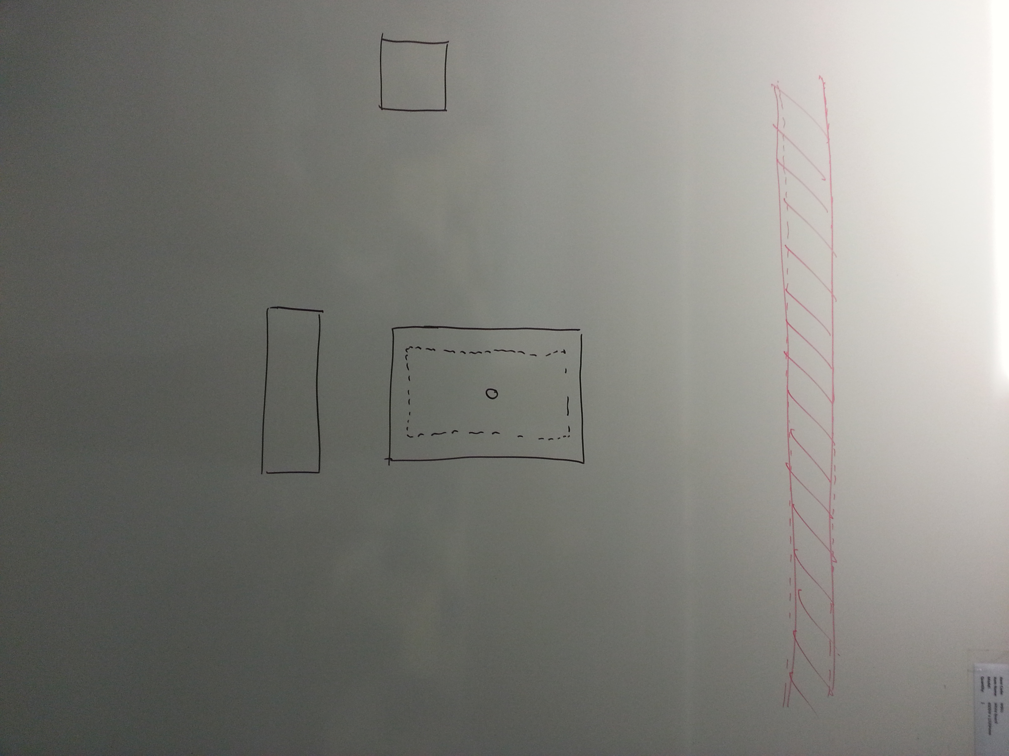

Diagram ofBase (Searching position, distance diagram)

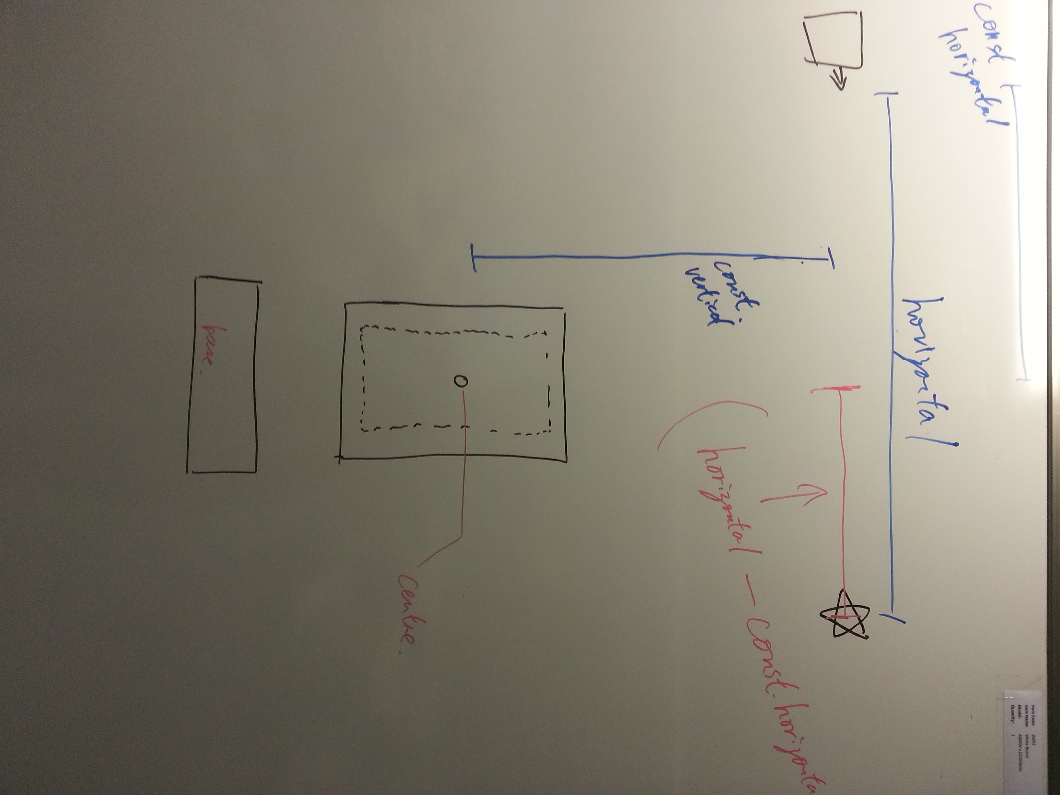

The distance between Prospector and the target is set as variable Horizontal

The short distance perpendicular from the center to the way of prospector (horizontal) is set as Const.Vertical

Horizontal**-**Const.Vertical**=**Corrected Horizontal

Displacement

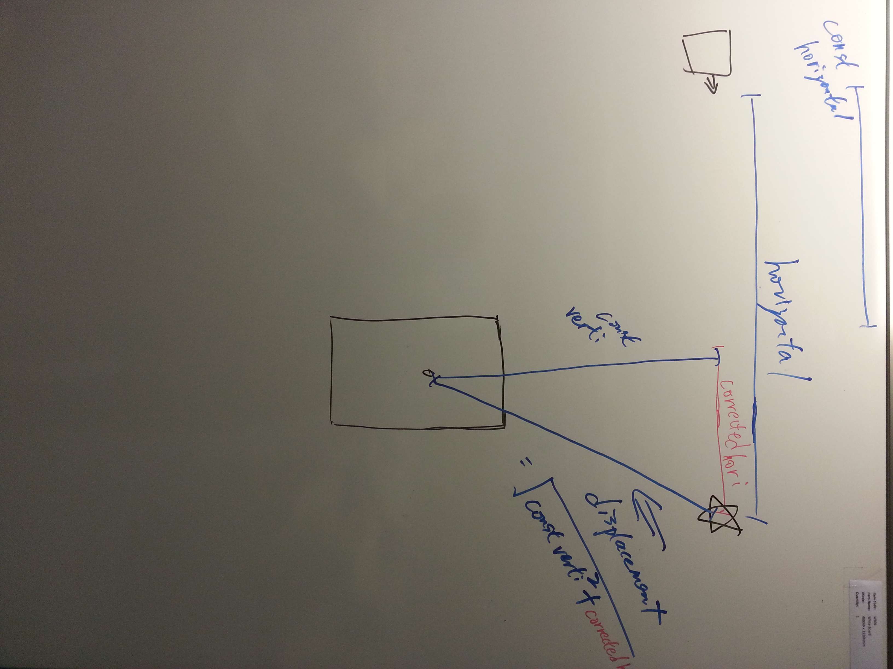

Displacement =Sqrt.(Const.vertical ^2 + corrected_horizontal^2)

Calculating the angel

True bearing :

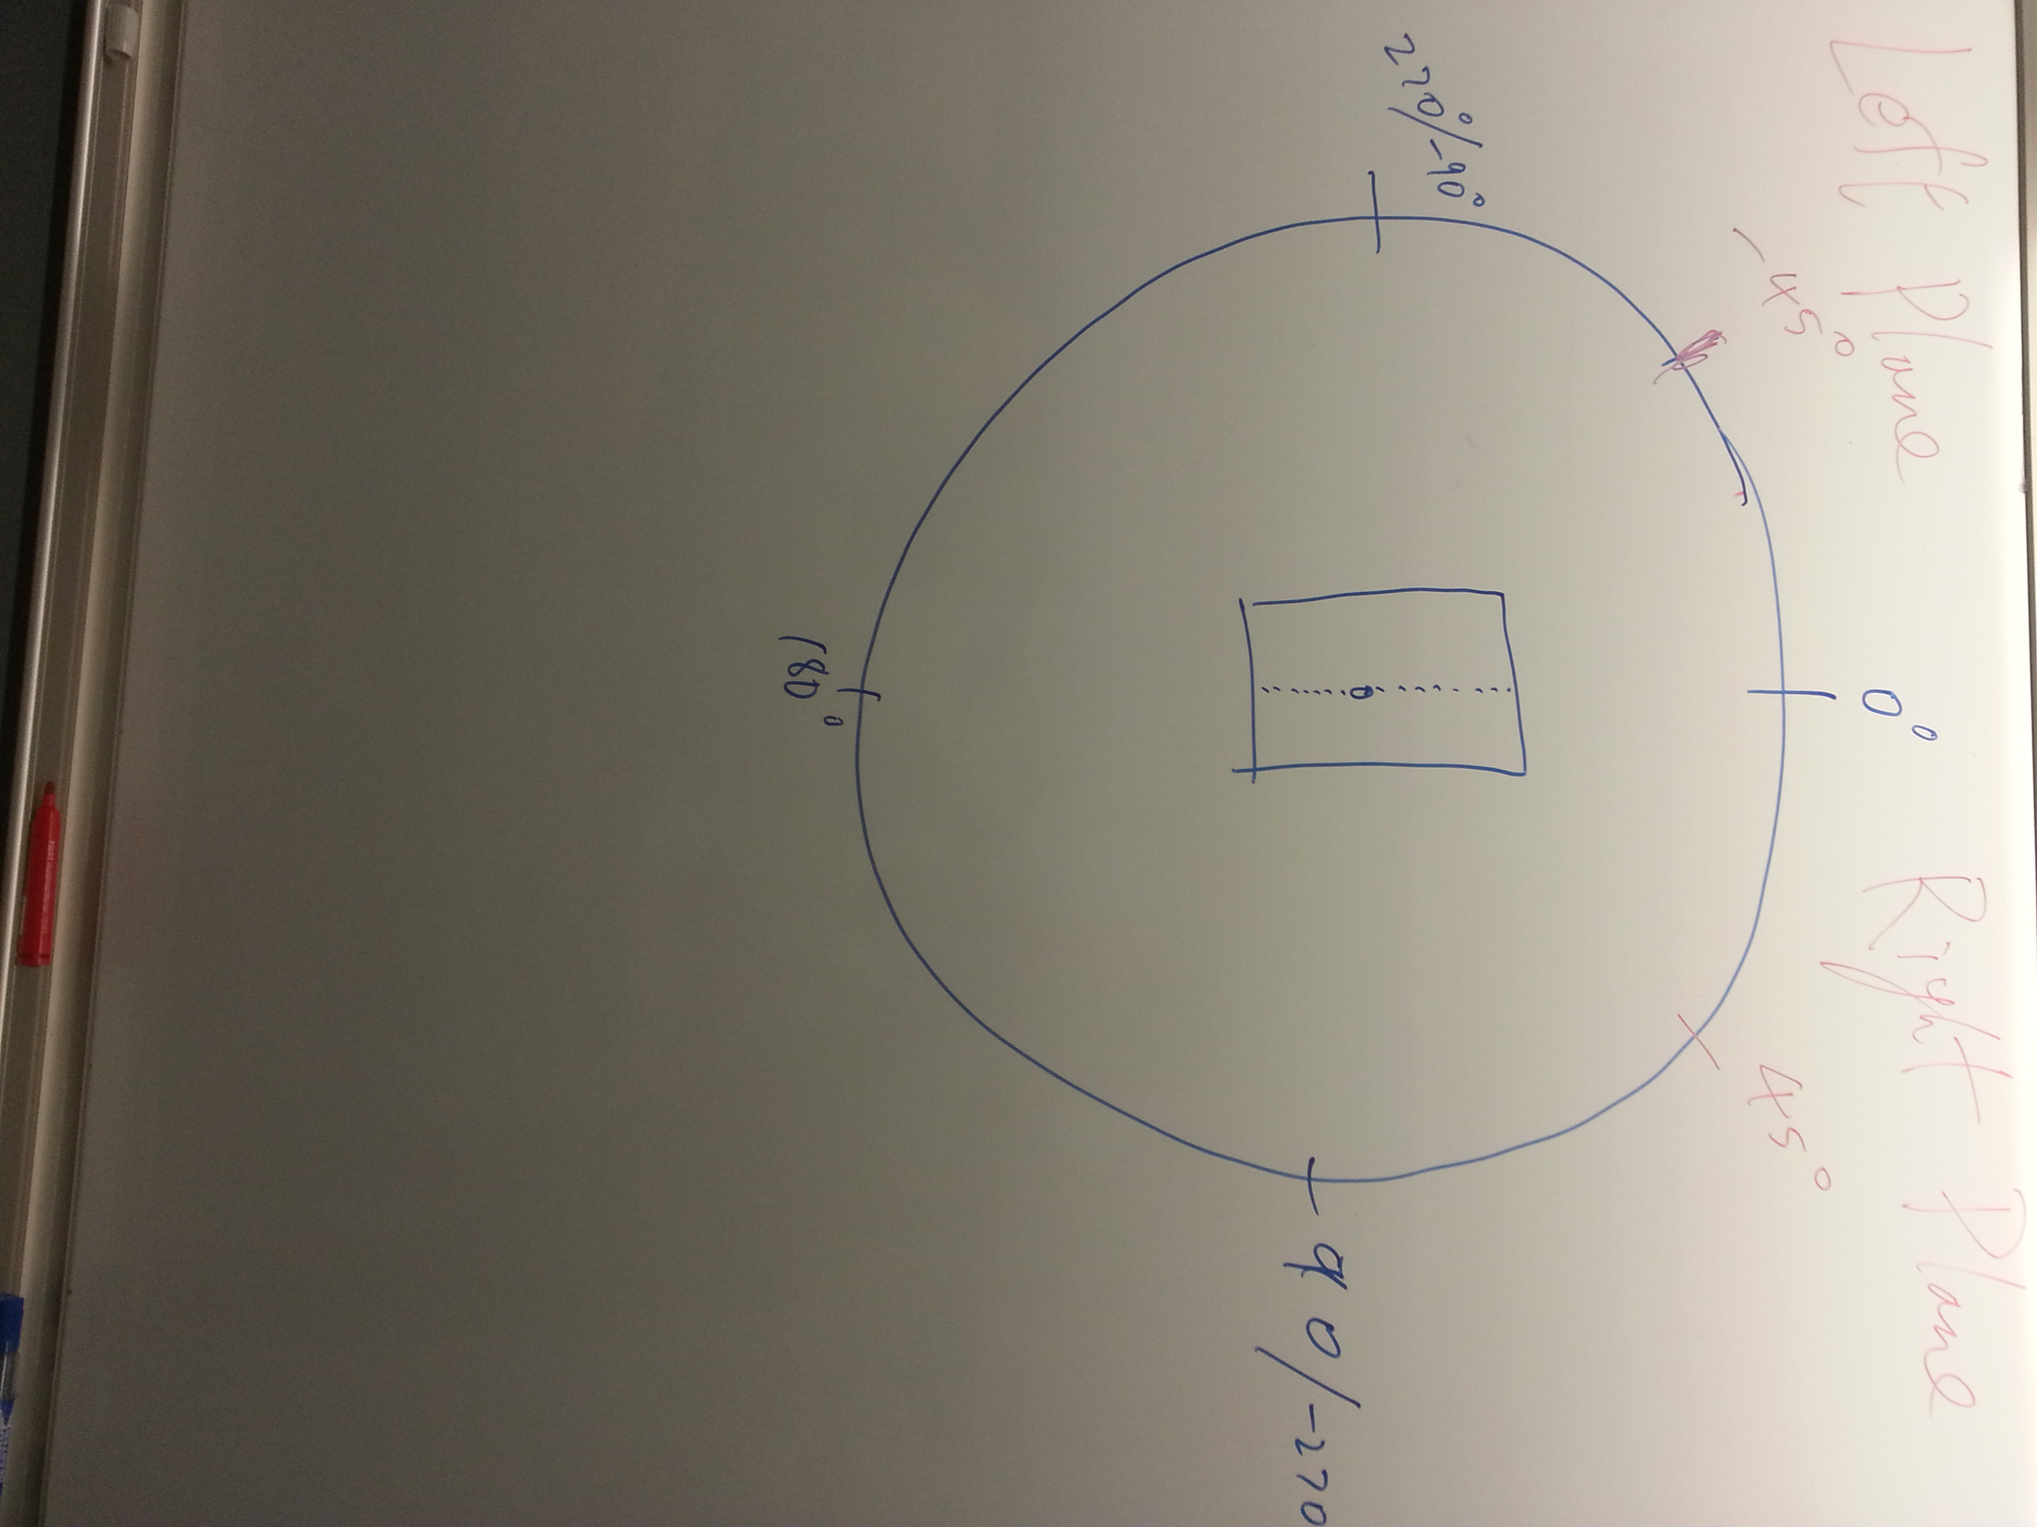

And we set the mid line be 0 angle

Clockwise motion towards positive angle

Anti-clockwise motion towards negative angle

Using Tangent function :

Case : Target on Right Plane

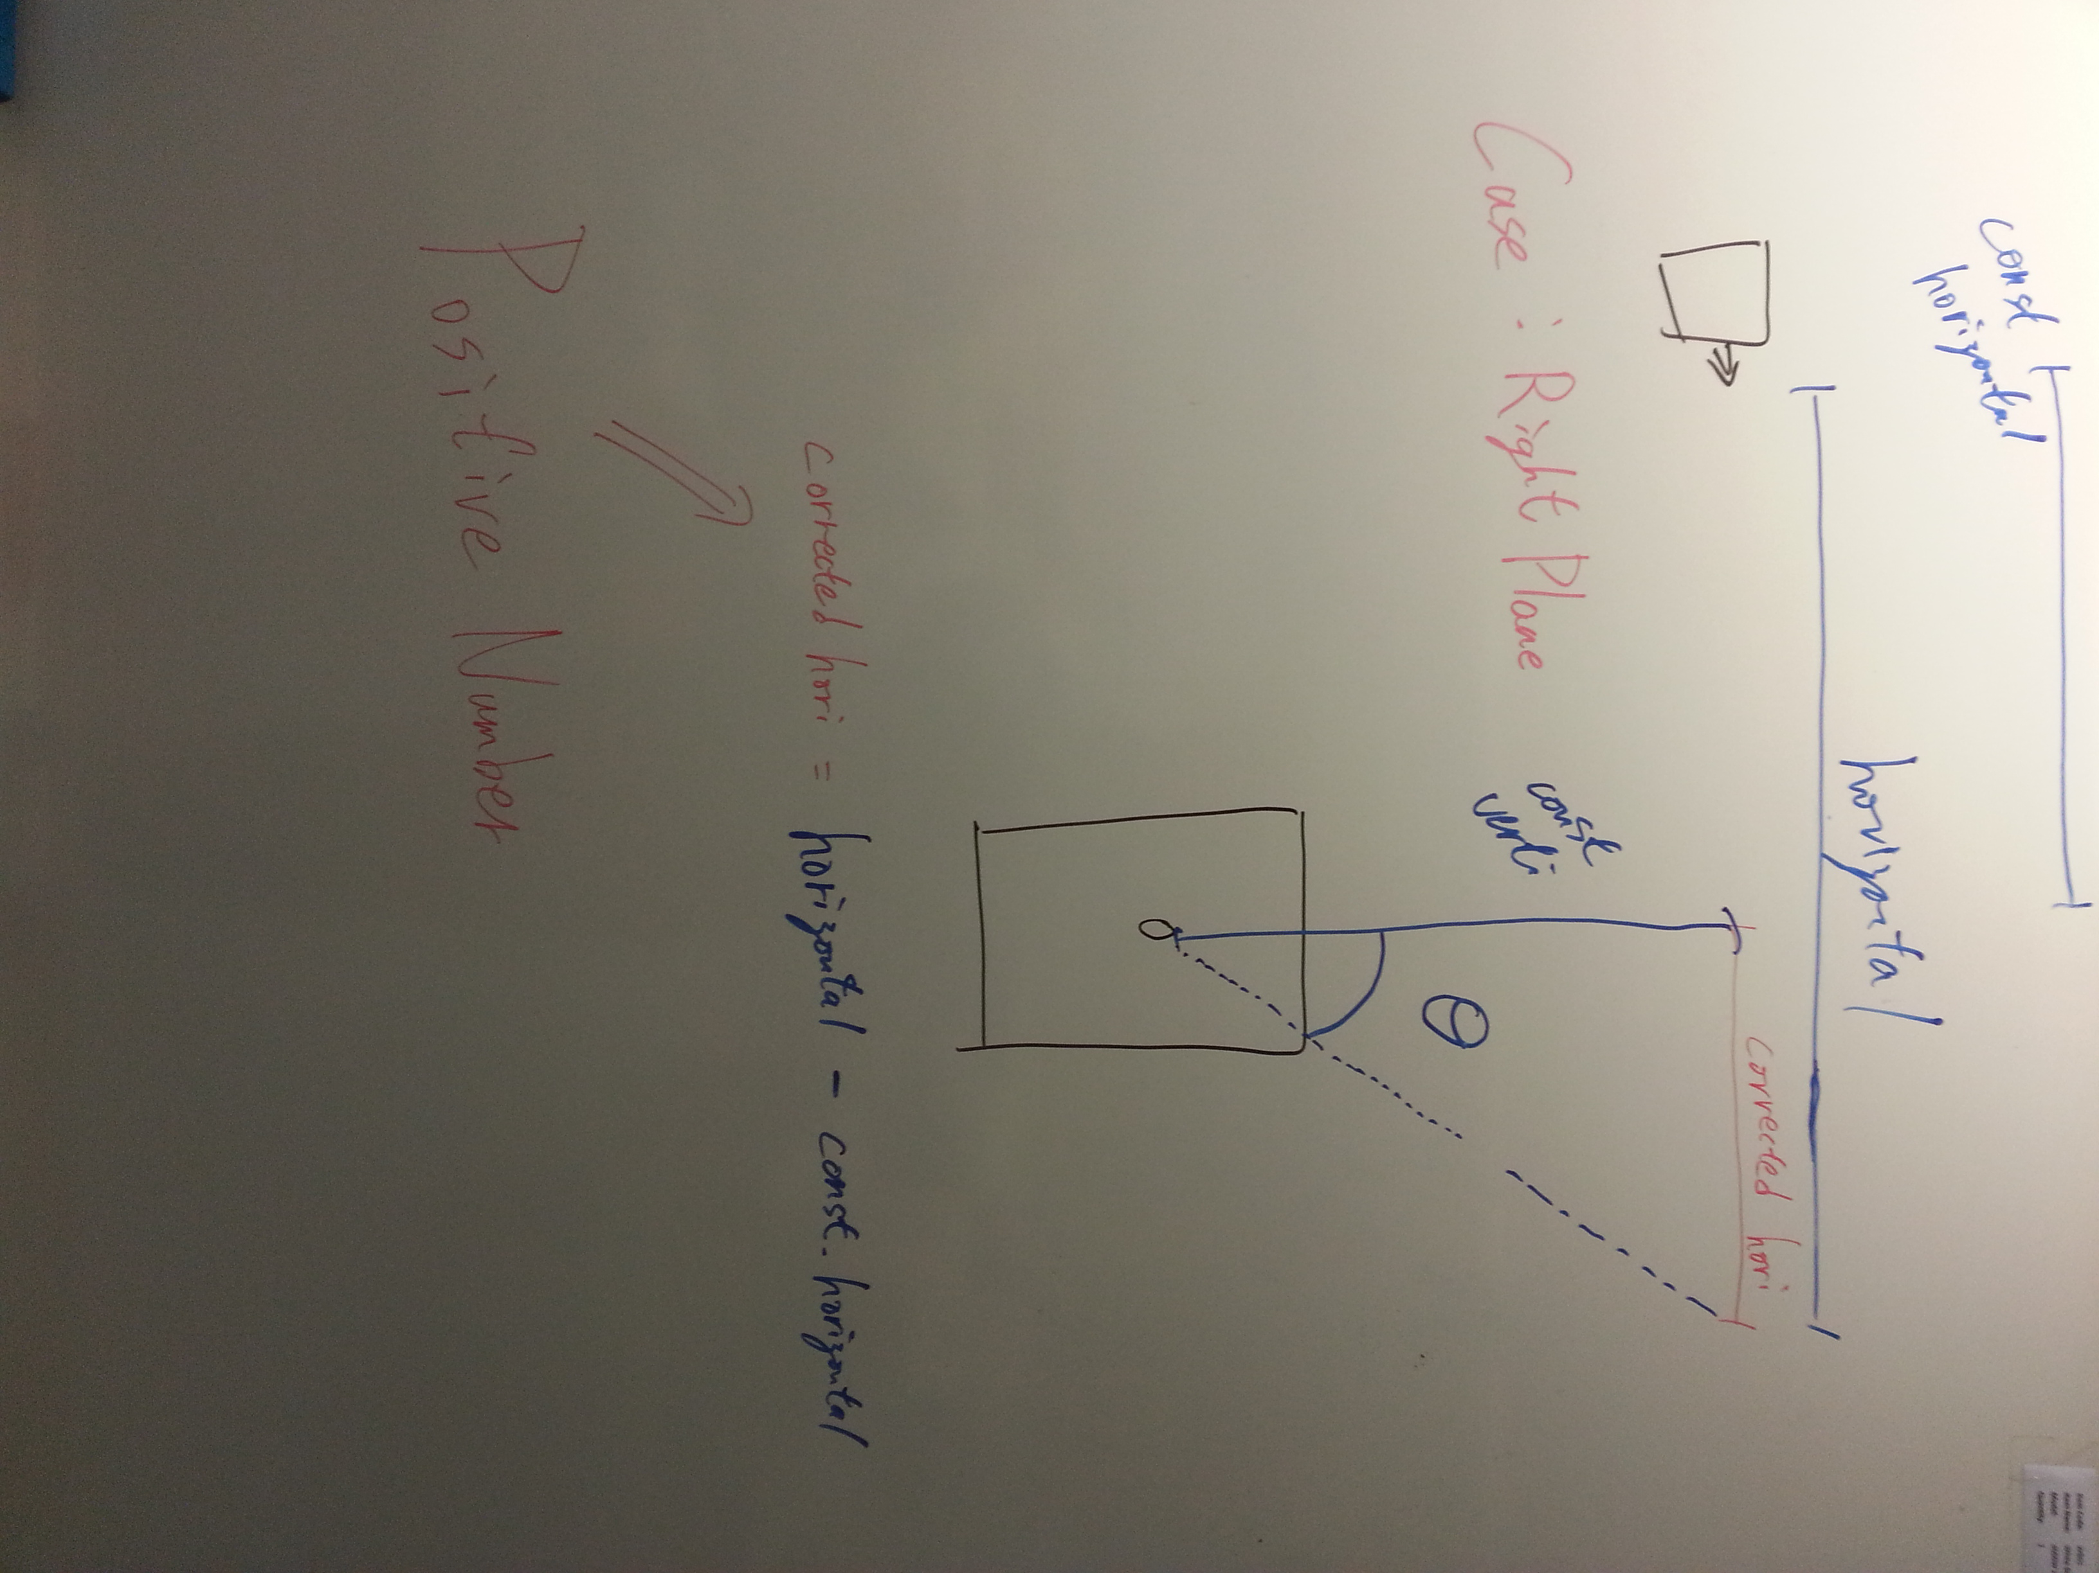

Becausethe target is on the right plane, Corrected horizontal is a *positive* number,

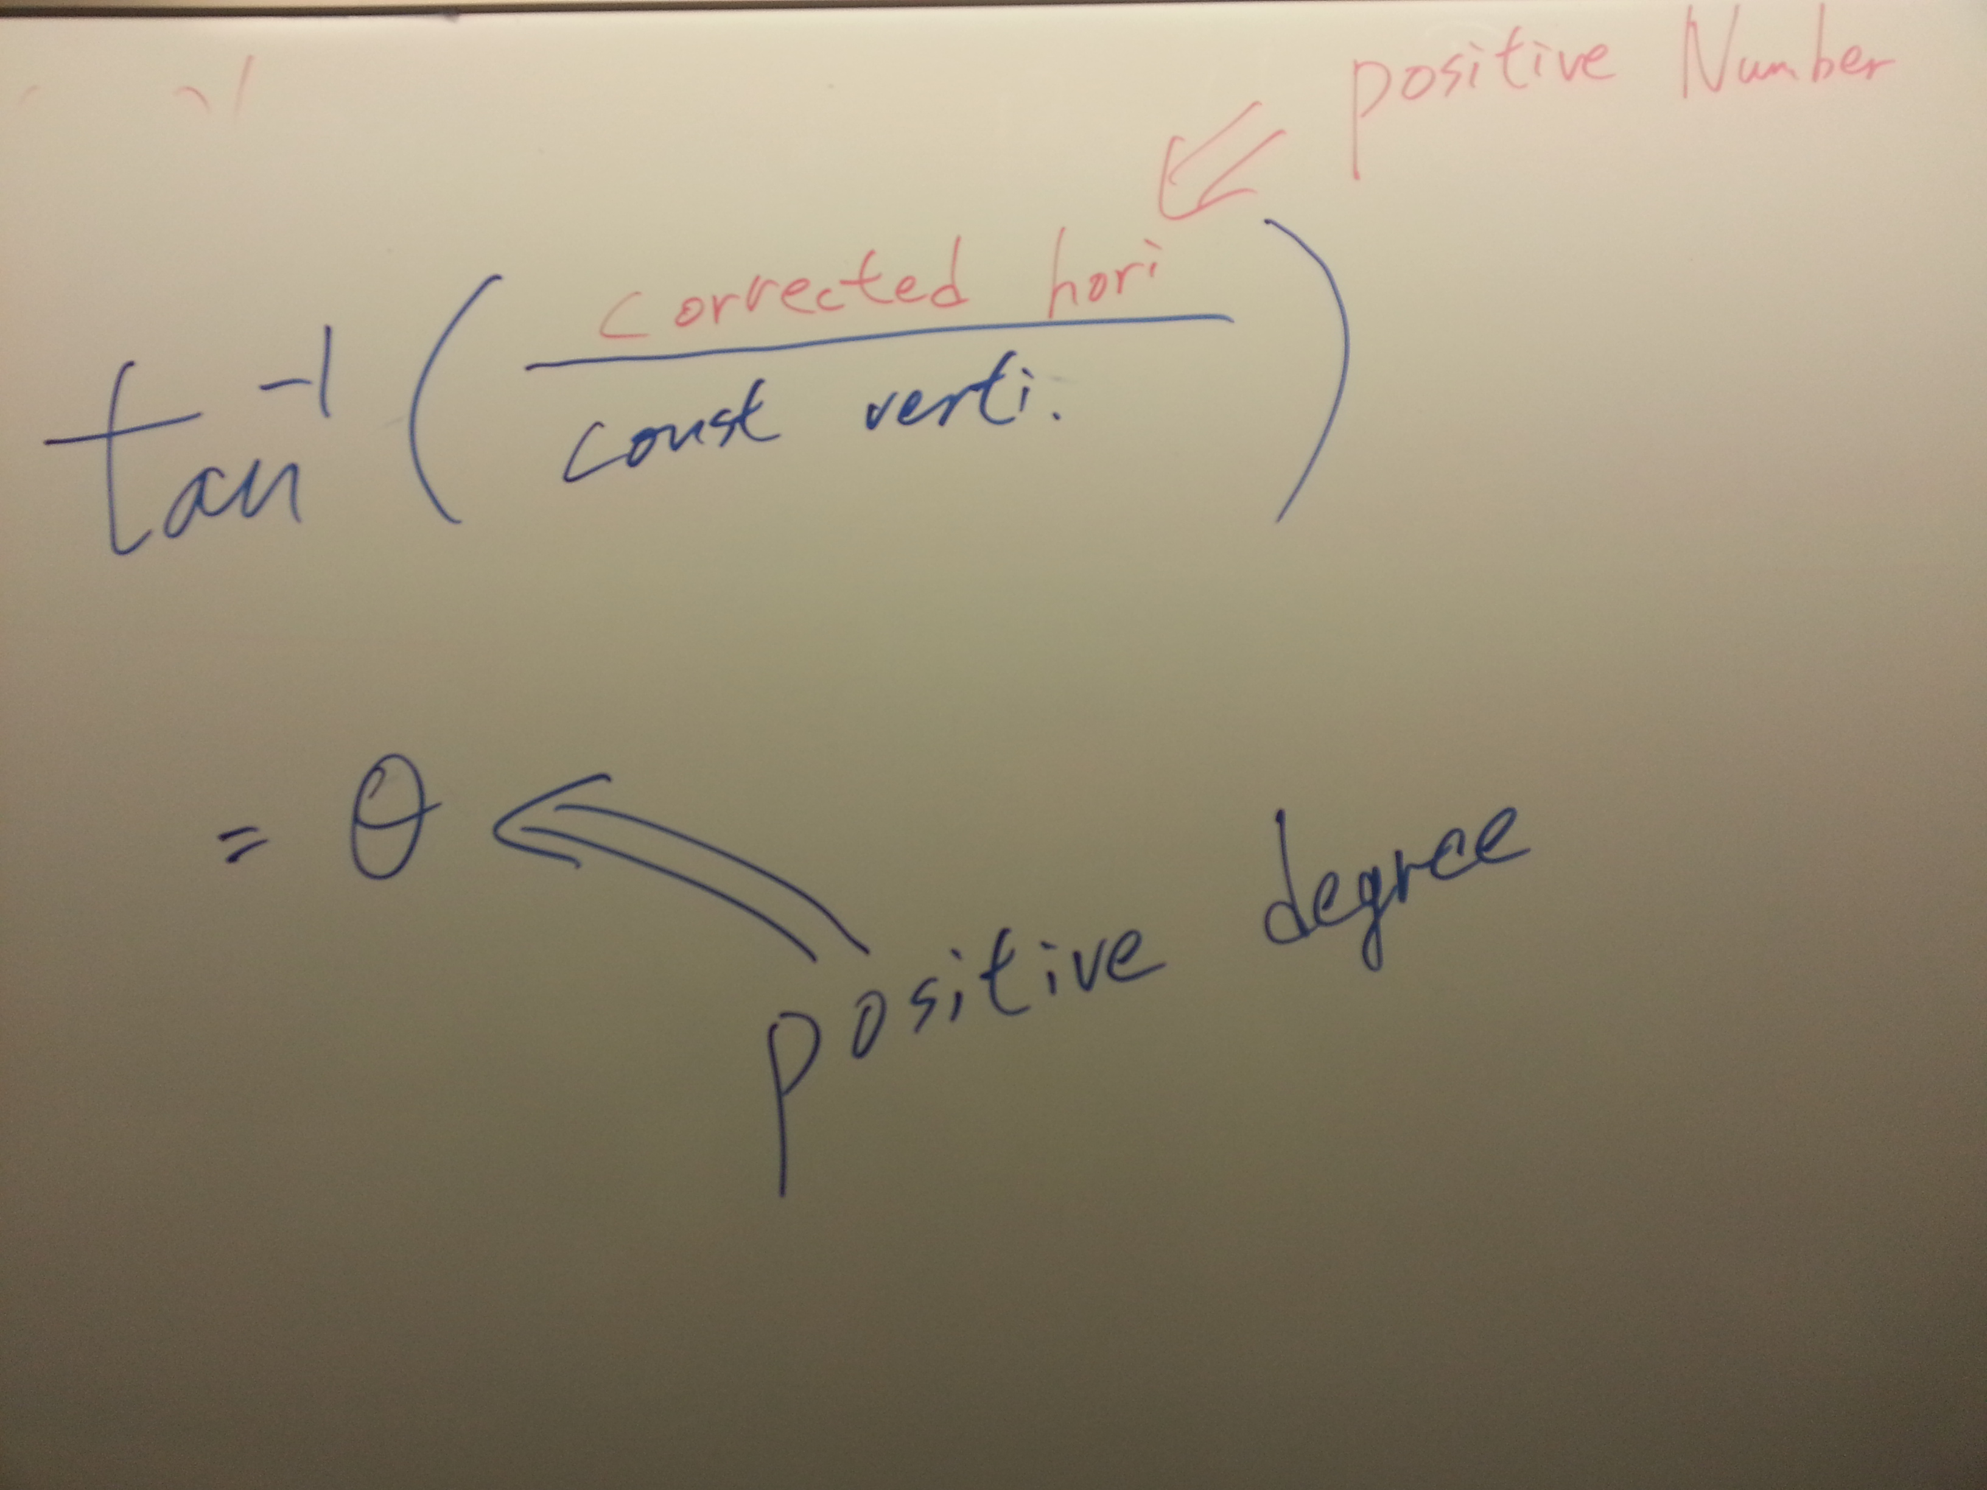

After tangent calculation, the angle will be a **positive** angle.

Case : Target on Left Plane

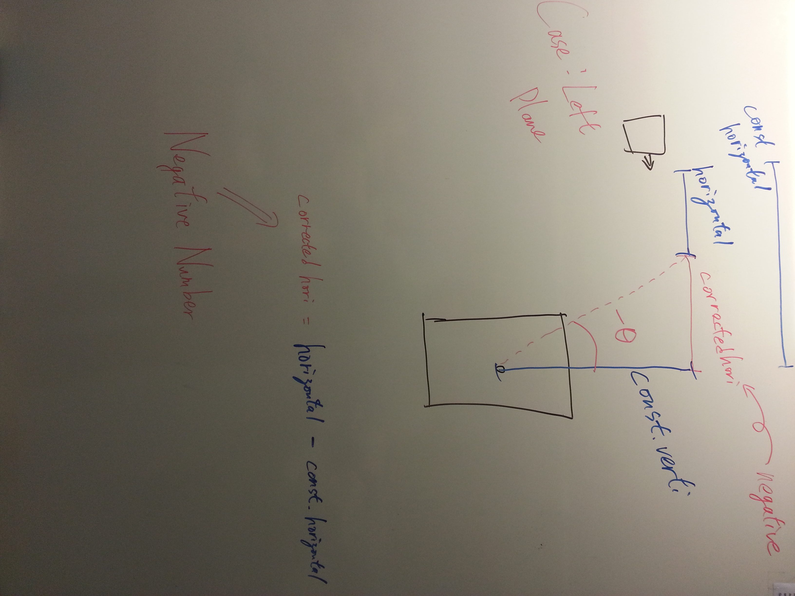

Becausethe target is on the right plane, Corrected horizontal is a *Negative* number,

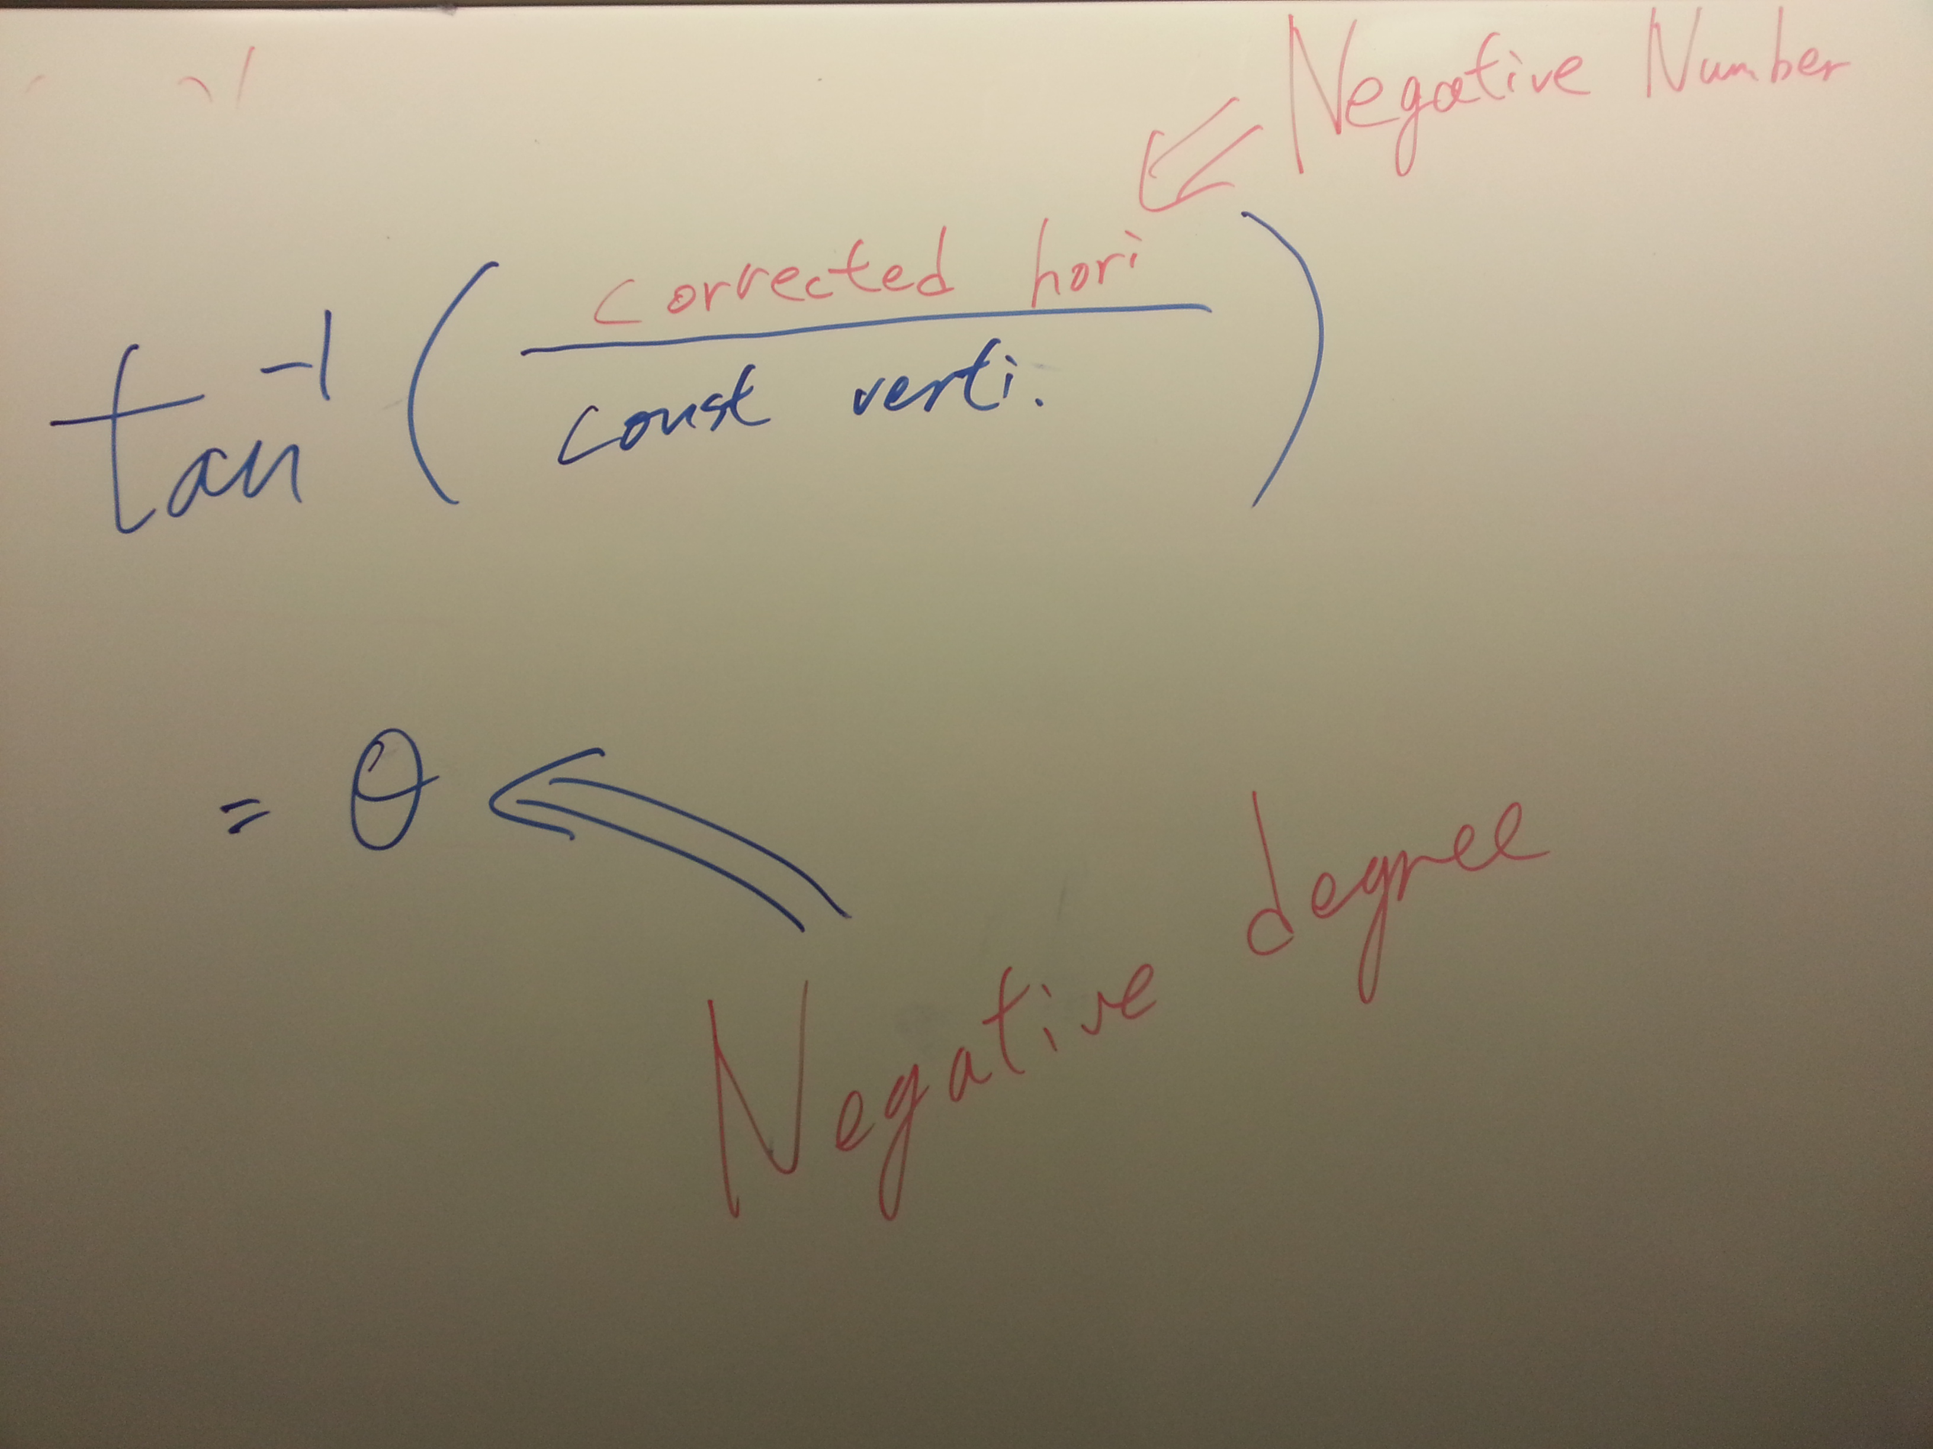

After tangent calculation, the angle will be a **Negative**angle.

Star Network system concept

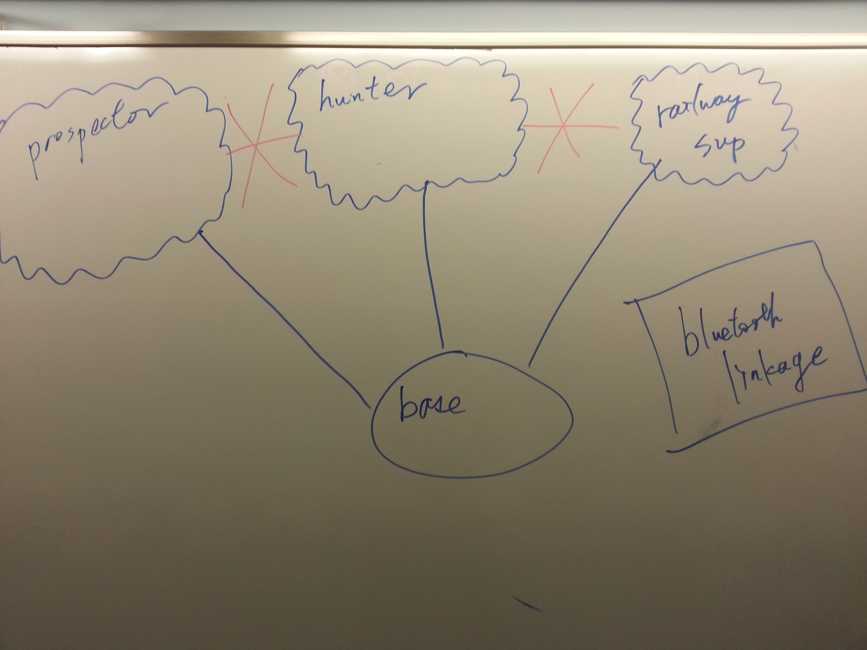

In order to have a clear mind for programming, an easy way for debugging is one of the main skills

We have used star network system in our programming, which we can just debug the linkage problem in the program of base. Base is acted like a bridge.

# Program Feature :Prospector

The running process of the prospector’s program is set to be like that:

Keep turning and moving until the resources are found or the target area is finish.

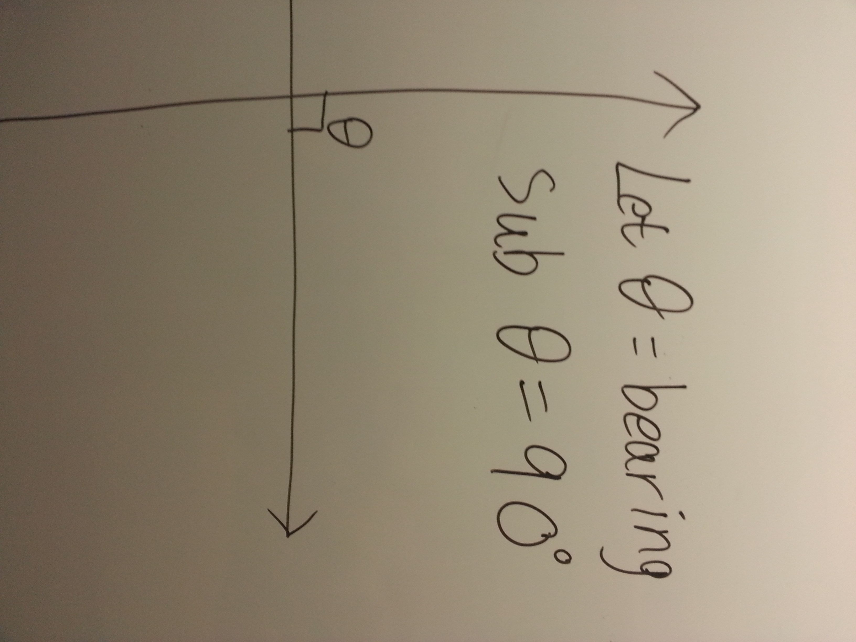

After the prospector moving out of the base area, it is assumed that it is facing to the front, and we let the bearing be 90 degree.

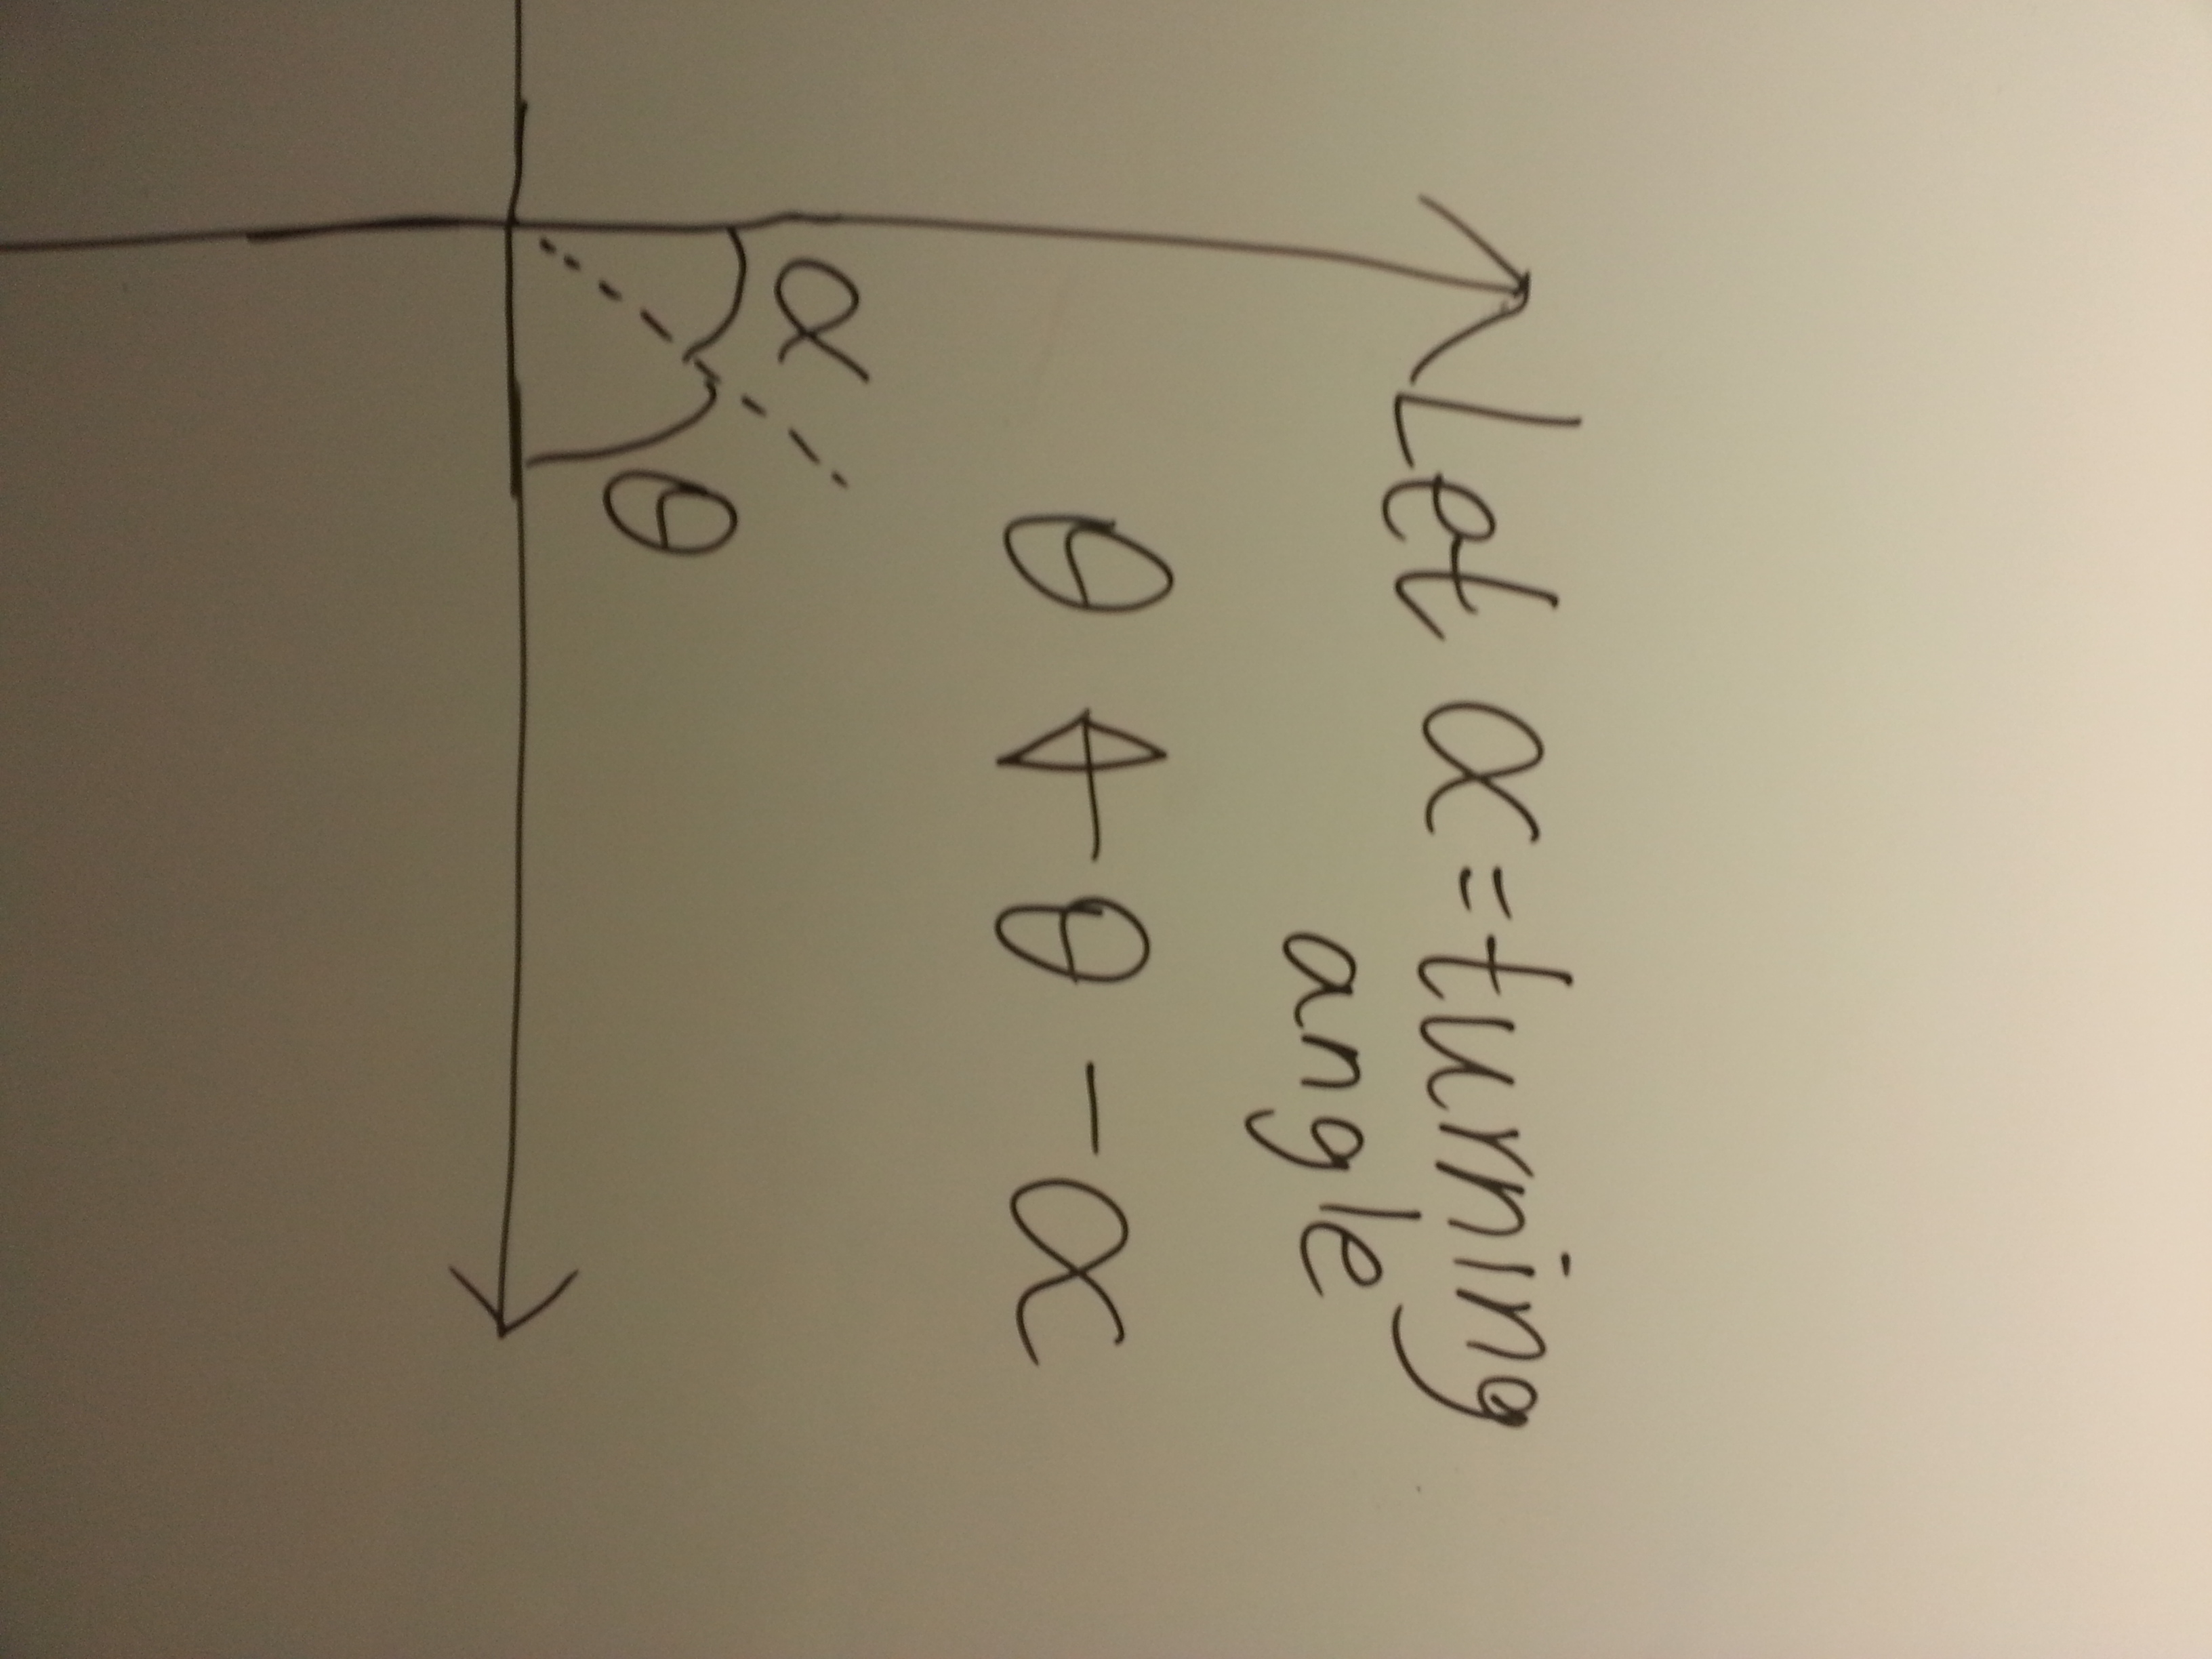

The next step is turning.

The prospector will automatically record down the turning angle. Then, the bearing of the prospector will equal to (original angle - turning angle).

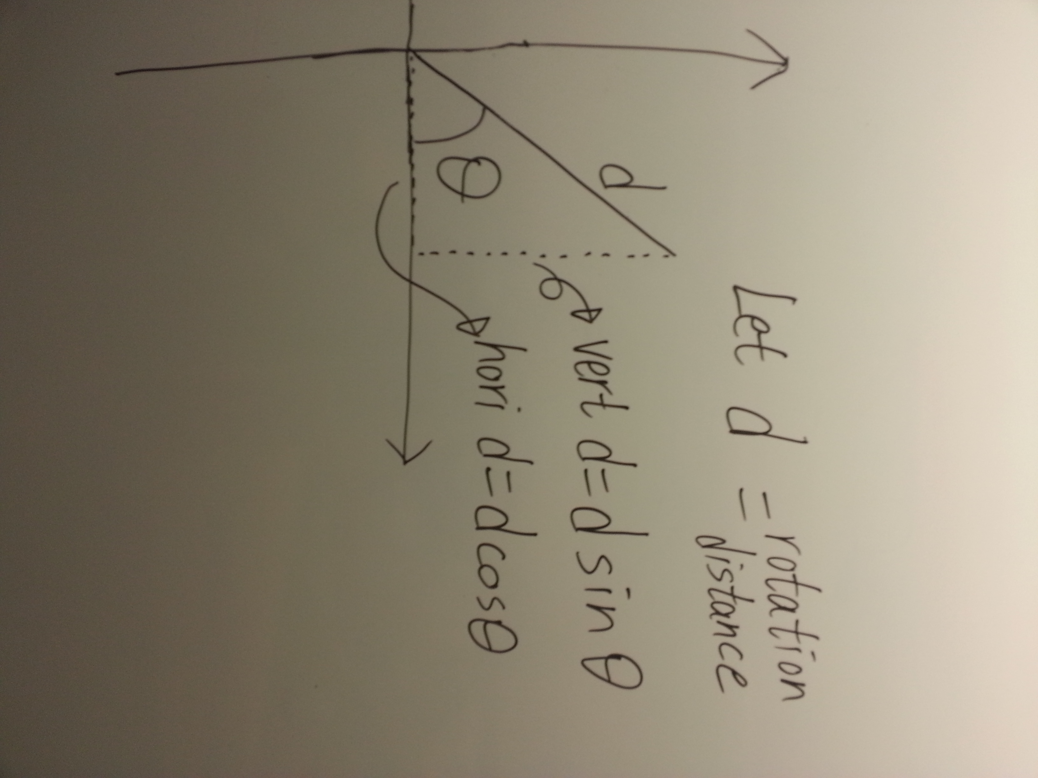

After that, the prospector will move forward untilthe resources are found or it meet the edge of the target area.

Then, the program will make use of the bearing and the recorded distance to calculate the vertical and horizontal distance.

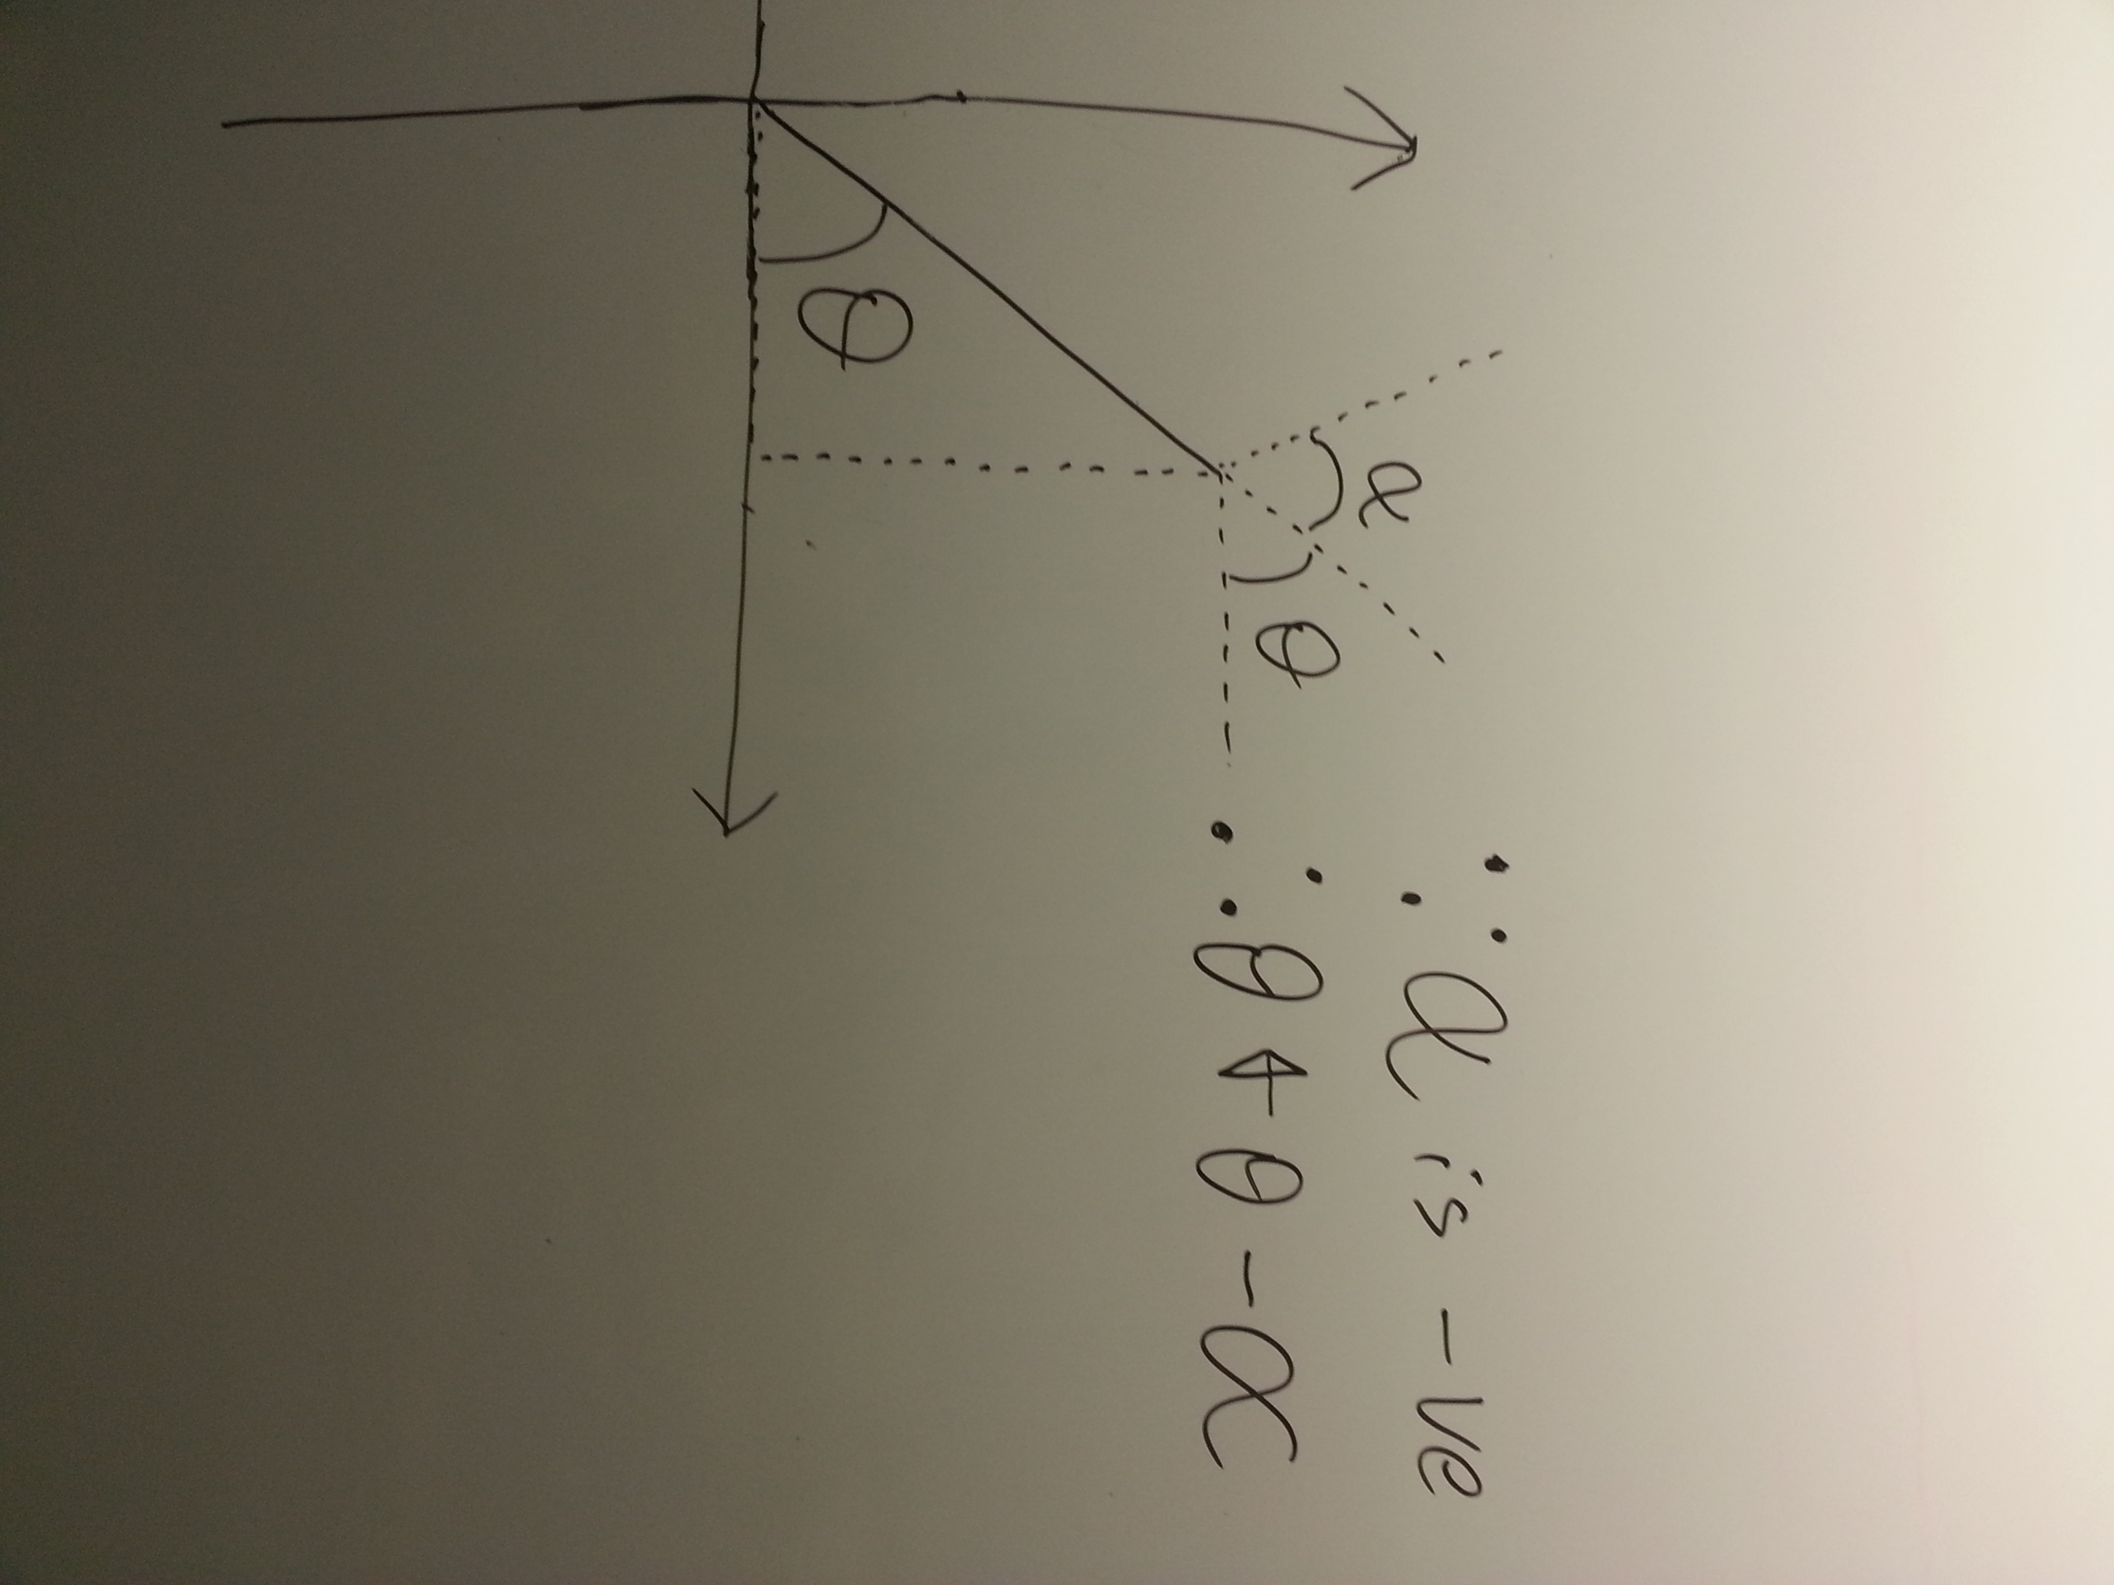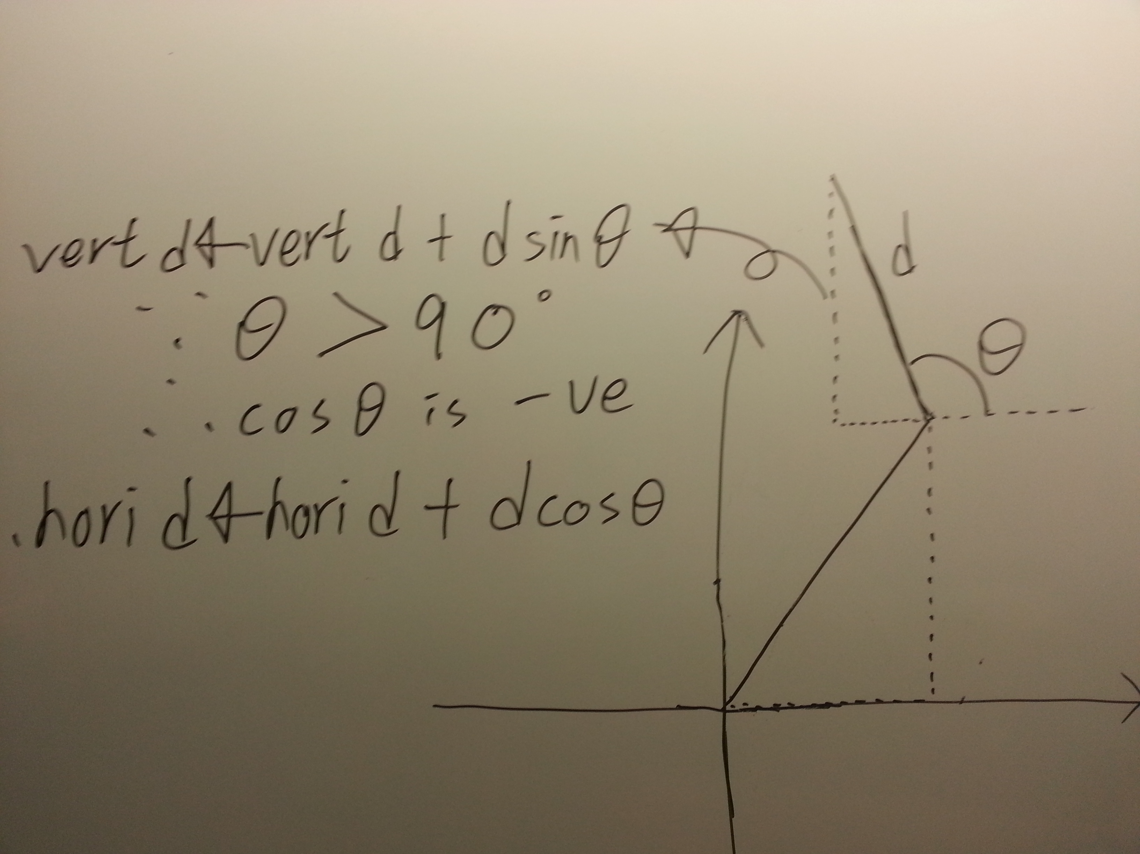

Repeating the turning and moving, the vertical and horizontal displacement will still be calculated no matter how the motion of the prospector is, because the program is making use of the coordinate concept in mathematics

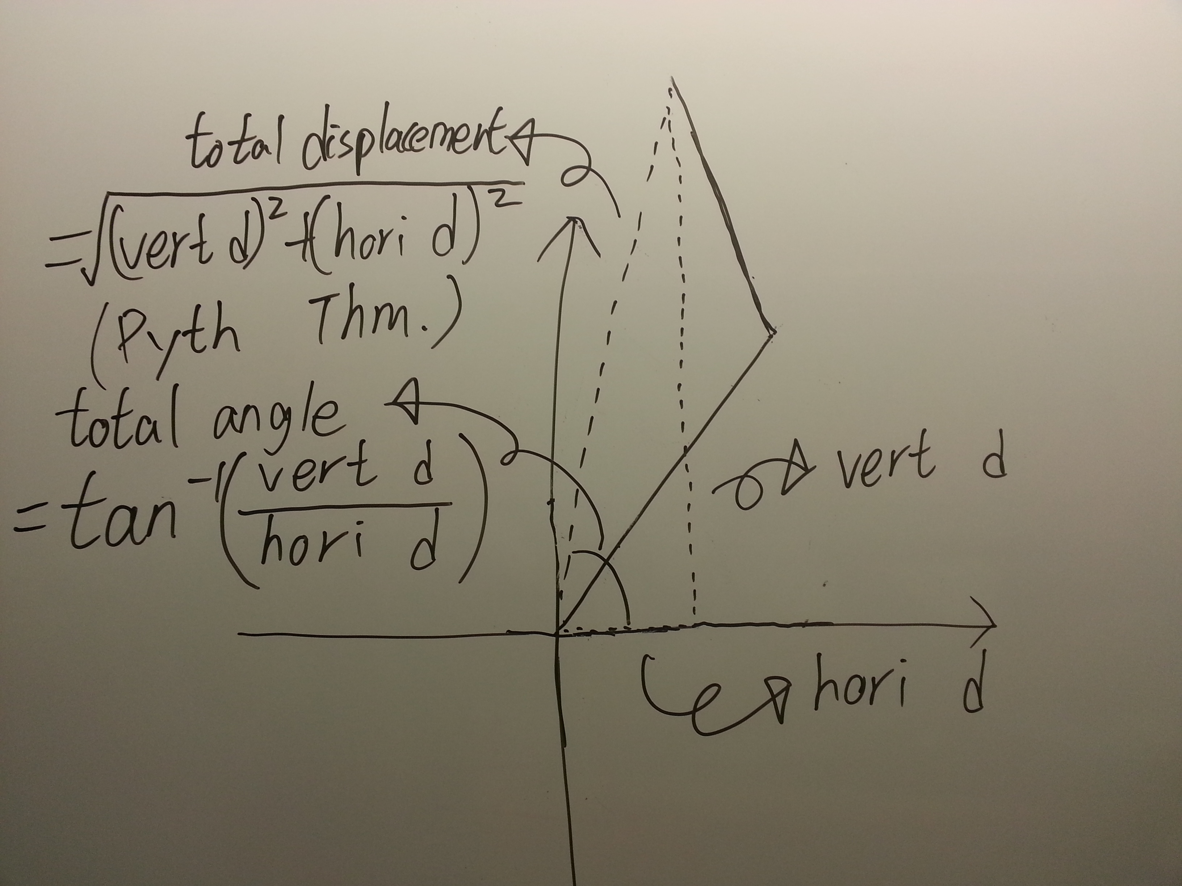

When the resources are found or the target area is finish, the prospector’ program will take the total vertical and horizontal displacement to calculate the total displacement and the bearing from the position of it and the starting point.

Finally, the prospector will face to the starting point and go back to the base.